Exploring the Parallelogram through Symmetry
Walter Whiteley, York University
January 2006, GSP Users Group

Activities with Parallelogram Symmetries Sketch

1. Consider the geometry problem: For a quadrilateral, |AB=|CD| and |BC|=|DA|.
Prove that <ABC is congruent to <CDA. Write out your proof.

2.Using the first three Tabs explore the two images for this information.
Do they change how you prove the congruence?
Do they change what transformation transforms one triangle to the other?

3. Look at Tab 4. What are the possible congruences of AC to CA?
Look at Tab 5 to see how these congruences apply to the quadrilaterals.

4. You have seen that the parallelogram picture goes with a half turn symmetry.
Do all parallelograms have this symmetry?
Is every quadrilateral with a half-turn symmetry also a parallelogram?

5. Does a half-turn always take a line to a parallel line? Why? (Explore with Tab 6.)
6. Consider a direct (non-analytic) proof that two lines related by half-turn symmetry cannot intersect in the plane (Tab 7). [Hint: Imagine they intersected. Take a half turn – where is the point of intersection now?]

7. Consider all the properties you are used to for a parallelogram (equality of angles, how the diagonals intersect, equality of sides, … ).
- How easy is it to prove these properties if you know there is a half-turn symmetry?
- If you had to prove one of these properties from two of the other properties, would you use a congruence? Which congruence would that be?

8. What is the name for the other image from the original problem? Is that type of quadrilateral characterized by the congruence you observed?

Extensions:
What if the original problem was posed in 3-space? The proof would still hold – but what would the symmetry be?

What would a half turn symmetry generate on the sphere? Which properties would the figure share with the parallelogram?

What symmetries characterize the Square? The Rhombus? The Kite? The Rectangle?
(See the attached article on symmetries for other quadrilaterals).

May 13, 2005

Making Sense of Transformations and Symmetry - the Heart of Geometry

Walter Whiteley and Lily Moshé

According to the famous German mathematician Felix Klein (1849-1925), geometry should be done in terms of symmetries or transformations (actually, he defined geometry as the study of properties of space that remain unchanged under given transformations). Doing geometry with the perspective of transformations and symmetries is more powerful than the traditional way through ruler and compass constructions. Using transformations to solve geometry problems can provide short and elegant solutions that would otherwise take a lot more time and space. For the students participating in mathematical contests, having this tool can make all the difference in their performance.
In addition to this, emphasizing symmetry and transformations in the classroom is an example of visual/kinesthetic teaching. This approach helps to familiarize students with geometric objects and properties in a less formal and a more experiential and practical way. It provides multiple representations and supports more diverse learning styles.
Some researchers in mathematics cognition (for example, Duval (2002)) believe that the difficulties experienced by math learners often occur in the transformational stages of reasoning (when a mathematical object needs to be represented in a different way, such as going from an equation to a graph). Recent research has shown that students’ ability to transform geometric objects is related to their efficiency in numeracy, in particular, addition/subtraction strategies (Wheatley, 1998). In addition to this, it appears that thinking in a “transformations mode” is natural for young children (Lehrer, Jenkins, & Osana, 1998). Since practicing mathematicians, biologists, chemists and engineers employ spatial and transformational reasoning (Barry et al., 2002; Whiteley, 2004), we need to keep transformations in the intermediate/senior curriculum, so that children’s transformation skills are not lost due to lack of their use. With all the benefits of transformational thinking in mind, more stress on the (sustenance and) improvement of their ability to transform will be beneficial for students.

Consider the hierarchy of quadrilaterals on page 1. This hierarchy relates various properties of quadrilaterals in a structured way. It underscores similarities and differences between the quadrilaterals and gives quadrilaterals partial order.
The hierarchy can be constructed in different ways, but in our experience, the most elegant way of defining it is in terms of symmetries. The hierarchy relates regularity of a shape to its symmetries. A generic quadrilateral has no symmetries. Which quadrilaterals have exactly one symmetry? A kite has one mirror symmetry through a pair of opposite vertices, an isosceles trapezoid (or butterfly) has a mirror symmetry through a pair of opposite edges, and a parallelogram has a 180° rotation (half-turn) as its symmetry. Since a rhombus is a kite in 2 different ways, it has 2 symmetry lines. Since a rectangle is an isosceles trapezoid in 2 different ways, it has 2 symmetry lines. Since a square is a rhombus and a rectangle, it has 4 symmetry lines.
Notice that the rhombus and the rectangle not only have 2 reflection symmetries, but also a half-turn symmetry, and a square has a quarter-turn symmetry. When we compose the two reflection symmetries, we get a rotation. Just as we can compose functions, we can compose transformations. A composition of two isometries (transformations preserving all distances) is an isometry. Here are some questions on composition of symmetries: What is the composition of 2 translations? 2 rotations with the same centre? 2 reflections in parallel lines? 2 reflections in intersecting lines? 3 reflections through the same point?
Symmetries are such fundamental properties of geometric figures that we can actually define shapes in terms of their symmetries. For example, we can define a rhombus as a quadrilateral with two mirror symmetries passing through its vertices. Can you prove that all of the properties that are usually associated with rhombi (all sides congruent, opposite angles congruent, perpendicular bisecting diagonals, diagonals as angle bisectors) can be derived from rhombus’ symmetries? Can you define other quadrilaterals in terms of their symmetries? Notice that most quadrilaterals can be defined in several ways and look for “minimal” definitions. For example, check that a square can be defined as a quadrilateral with a quarter-turn symmetry!
When proving congruences in figures, implicitly, we are showing that it is possible to move one object onto another so that all of their corresponding points coincide. The curriculum stresses using triangle congruences (side-side-side, side-angle-side and angle-side-angle) to prove congruences. However, rather than just quoting the triangle congruence that applies in a particular situation, it is more advantageous for students’ thinking to note the motion that takes corresponding sides and angles of the two figures on top of one another, and not just the name of the congruence. A congruence is an isometry (in the plane a reflection, a rotation, a translation, or a glide reflection). Likewise, similarities can be seen in terms of dilations or contractions.
Once you start thinking of quadrilaterals in terms of their symmetries, you will find new ways of constructing them in Geometer’s Sketchpad. Rather than using the “construct” menu, it is of more benefit to encourage students to use the “transform” menu. Emphasizing the “transform” menu in GSP can serve as a way to develop and reinforce students’ transformation skills. Think about how you can construct a square using the “transform” menu. Remembering symmetries of quadrilaterals and using them to sketch the quadrilaterals will facilitate better understanding of symmetries and how essential they are in geometry.
GSP brings numerous advantages to a mathematics classroom. One of the benefits related to transformations is its “locus” feature that enables one not only to drag points and dynamically alter a diagram, but also to see and analyze the trails left by moving objects. This quality makes motion more explicit and aids in student’s understanding of the motion, which is important in knowledge construction (Chaillé & Britain, 2003).
Another benefit of GSP and of the quadrilateral hierarchy is their insistence on inclusive definitions. When looking at the hierarchy, it is implicit that a rhombus is a kite and a parallelogram, and a rectangle is an isosceles trapezoid and a parallelogram. Similarly, the hierarchy makes it easy to answer questions such as “What is both a kite and a rectangle?” Constructing an object in GSP and dragging its points will necessarily pass through subclasses of figures. For example, it would be very difficult (if not impossible) to construct an isosceles trapezoid whose vertices cannot be dragged to create a rectangle or a square. This reinforces the fact that a square is a rectangle, and both the square and the rectangle are isosceles trapezoids.
Inclusive definitions fit correct mathematical reasoning, as the properties of figures get passed on from more general ones to ones with more regularity or more symmetry. For example, any theorem that we can prove for a trapezoid also applies to parallelograms, rectangles and squares. Exclusive definitions do not promote mathematical maturity and higher reasoning. Throughout the hierarchy and while using GSP, it is important to draw students’ attention to the inclusiveness of definitions. Inclusiveness relates different quadrilaterals and provides a mathematical structure which is imperative for students to grasp.
Notice that since the hierarchy of quadrilaterals is built on symmetry, we had to omit the general trapezoid. Unlike the isosceles trapezoid, it has no symmetries. We would like to note that although many textbooks make the mistake of exclusively defining a trapezoid as a quadrilateral with exactly one pair of parallel sides, the correct inclusive definition must say that a trapezoid is a quadrilateral with at least one pair of parallel sides, and hence allow parallelograms as a subclass of trapezoids.
Now, to illustrate the power of thinking with transformations, consider the following problem:
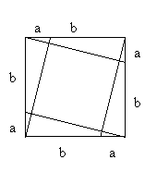
The sides of a square are split up in an a:b ratio and connected to the vertices as in the figure. Prove that the quadrilateral that is formed inside is a square.

If a student accepts “a quadrilateral with a quarter-turn symmetry” as a definition of a square, the proof becomes trivial: since the construction satisfies quarter-turn symmetry, the quadrilateral inside must be a square. There are other ways of proving this, however, none as simple and elegant as with symmetry.

To summarize, teaching transformations as the core of geometry has undisputable benefits to students. Symmetry is taught in elementary school and is almost instinctive for many students, and the notion of transformations fosters visual reasoning and the reasoning used by professional mathematicians. The use of symmetries, including those of 3D objects, is required in many other fields, such as stereochemistry (remember the thalidamide example?). The various symmetries capture the essence of each quadrilateral and underline associations between them, thereby reinforcing inclusiveness and creating a meaningful mathematical structure. Finally, symmetry is a central concept in mathematics. It underscores its structure and beauty.

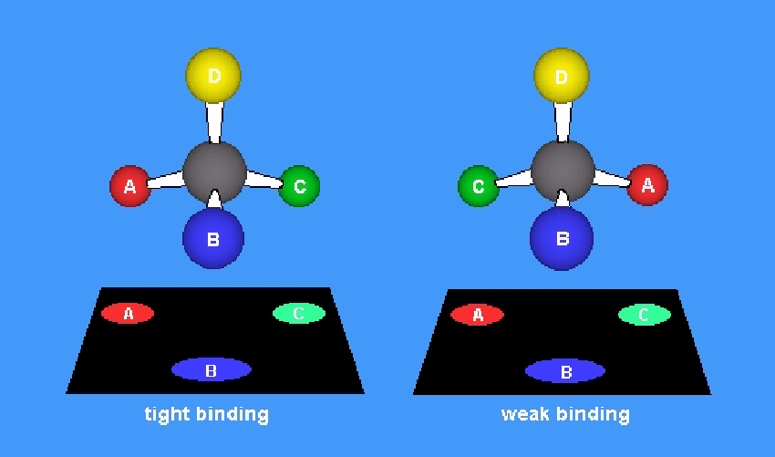
Two forms of thalidamide.
Our contact information:

www.math.yorku.ca/~whiteley
whiteley@mathstat.yorku.ca
lilychka@mathstat.yorku.ca

References
Barry, A. M., Berry, D., Cunningham, S., Newton, J., Schweppe, M., Spalter, A., Whiteley, W. & Williams, R. (2002). Visual Learning for Science and Engineering. ACM SIGGRAPH - Eurographics Campfire on Visual Learning. Snowbird, Utah. Available at http://www.siggraph.org/education/vl/vl.htm.
Chaillé, C., & Britain, L. (2003). The young child as scientist: A constructivist approach to early childhood science education. (3rd ed.). New York: Allyn and Bacon.
Duval, R. (2002). The cognitive analysis of problems of comprehension in the learning of mathematics. Mediterranean Journal for Research in Mathematics Education, 1(2), 1-16.
Lehrer, R., Jenkins, M., & Osana, H. (1998). Longitudinal study of children's reasoning about space and geometry. In R. Lehrer, & D. Chazan (Eds.), Designing learning environments for developing understanding of geometry and space. (pp. 137-167). Mahwah, NJ: Lawrence Erlbaum Associates.
Wheatley, G. H. (1998). Imagery and mathematics learning. Focus on Learning Problems in Mathematics, 20(2 & 3), 65-77.
Whiteley, W. (2004). Visualization in mathematics: Claims and questions towards a research program. Unpublished manuscript presented at the International Congress on Mathematics Education 10. Copenhagen, Denmark. Available at http://www.math.yorku.ca/~whiteley/Visualization.pdf.

