The conchoid of Nicomedes and trisection of angles
Jim Parks, SUNY-Potsdam
UGM – Phoenix 1/9/04

The conchoid of Nicomedes (280-210 B.C.) is determined by using a line m which passes through a fixed point P (the pole) and intersects a fixed line d (the directrix). Points A, B are taken on line m on each side of d and of equal distance a from d.
The conchoid is the locus of these points (some people call only the curve away from P the conchoid) as m is moved about P (move D on d or click on the "Animate m" button).
The curve nearest P has three different forms as a<b, a=b, or a>b, where b is the distance from the pole to the directrix (use the slider to change the value of a).

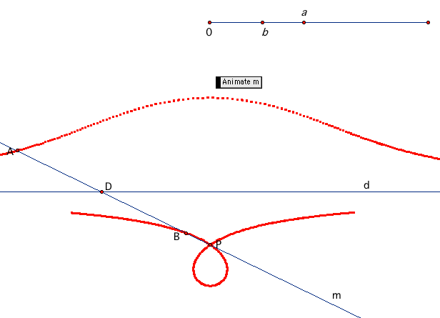

2.

Trisection of an angle using the conchoid
Given an acute angle, Angle ABC, drop a perpendicular from A to BC at D (click on Button 1) and construct a parallel line n to BC through A (click Button 2).
Construct a conchoid curve using B as the pole, AD as the directrix, and distance a = 2|AB| (click Button 3).
The intersection point of the conchoid and the parallel line n through A determines the trisector BH of Angle ABC (move H to intersect with n).
This is easily seen by connecting A to the midpoint F of GH and studying the isosceles triangles ∆AFH and ∆AFB (click Button 4).

